Assignment_1_Linux_Basics
Firstly, I created an empty folder named Linux_Basics_KaushalDandriyal
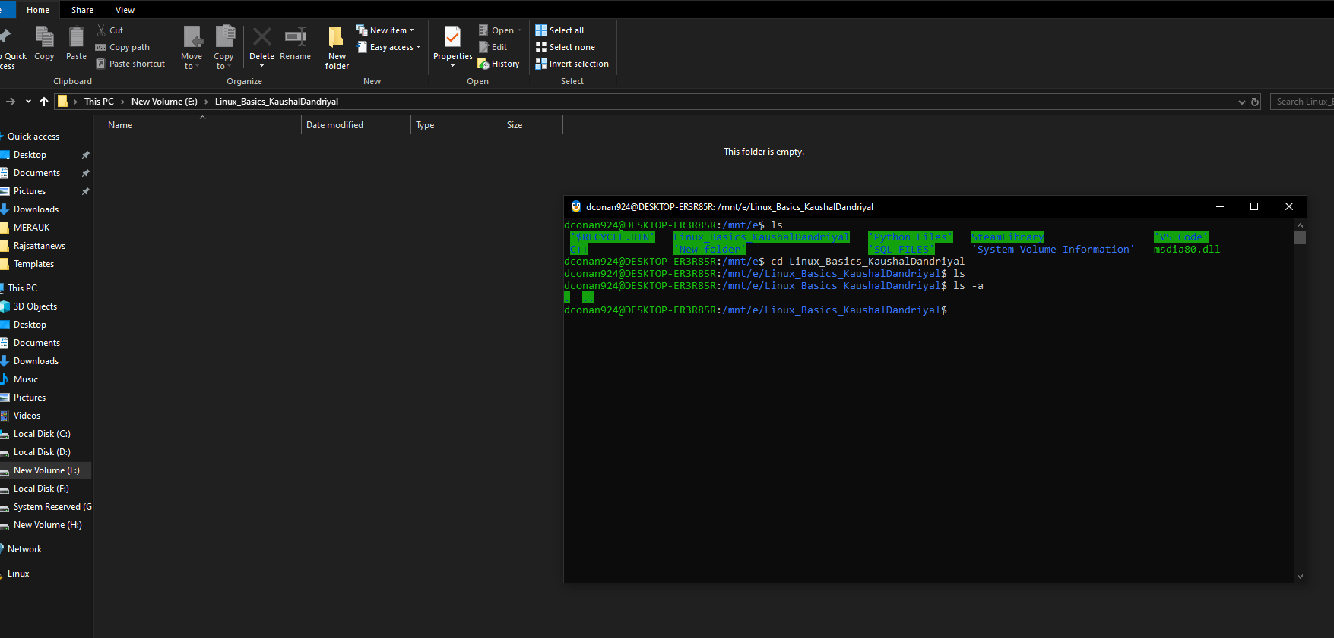

1. Creating and Renaming Files/Directories
1. Create a directory named test_dir using mkdir.
Explanation: mkdir is used to create directories.
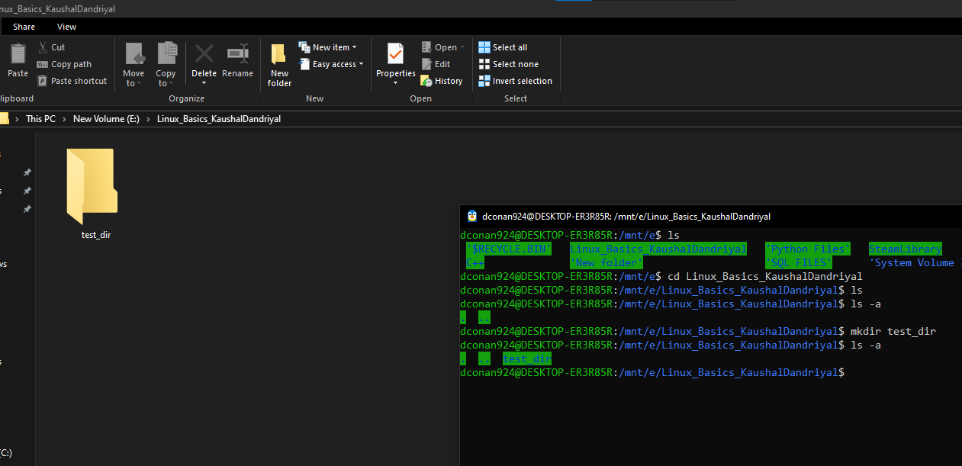

2. Inside test_dir, create an empty file called example.txt.
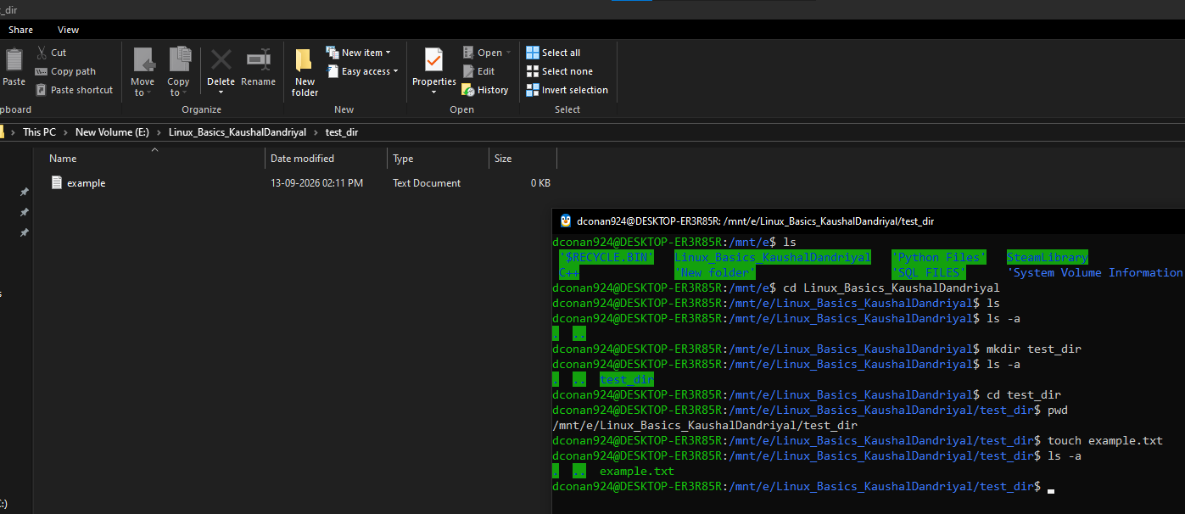

3. Rename example.txt to renamed_example.txt using mv.
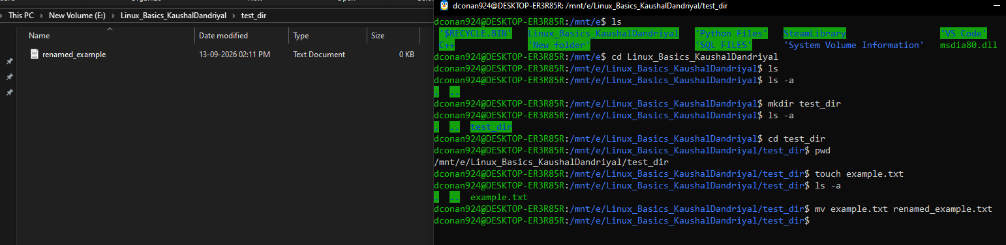

2. Viewing File Contents
4. Use cat to display the contents of /etc/passwd.
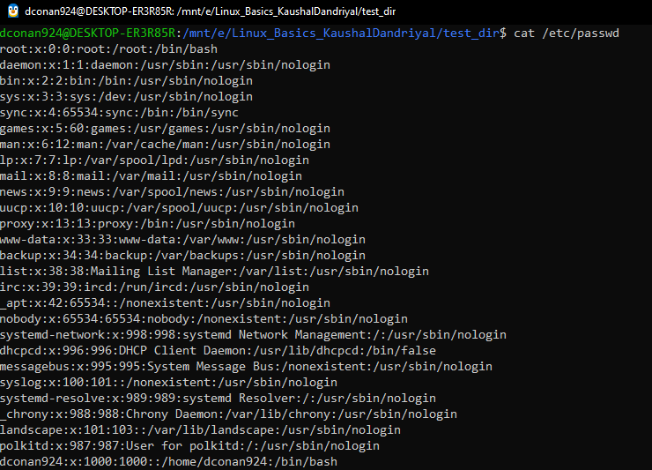

5. Display only the first 5 lines of /etc/passwd using head.
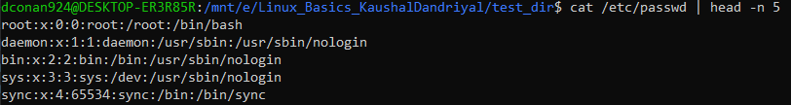

6. Display only the last 5 lines of /etc/passwd using tail.
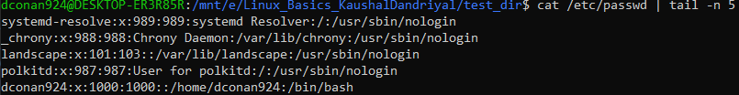

3. Searching for Patterns
7. Use grep to find all lines containing the word “root” in /etc/passwd.

4. Zipping and Unzipping
8. Compress the test_dir directory into a file named test_dir.zip using zip.
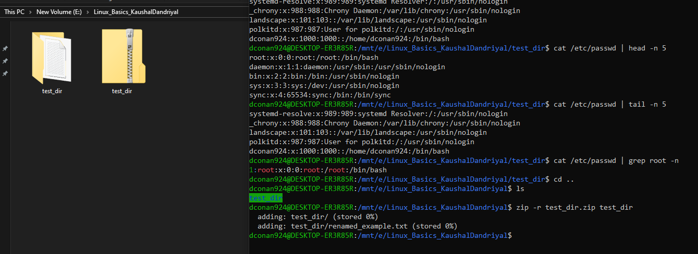

9. Unzip test_dir.zip into a new directory named unzipped_dir.
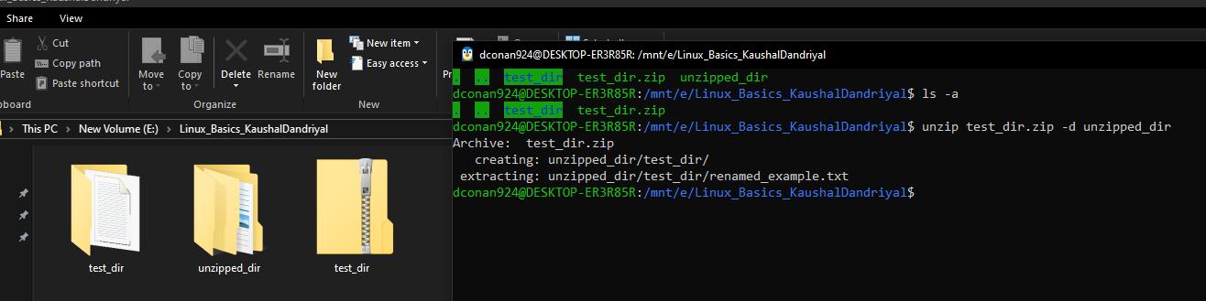

5. Downloading Files
10. Use wget to download a file from a URL (e.g., https://example.com/sample.txt).
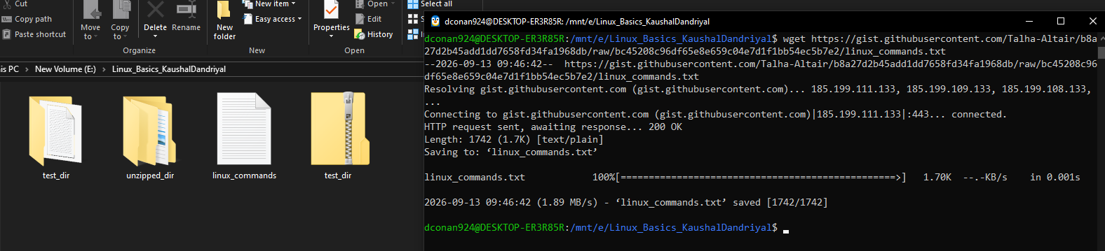

6. Changing Permissions
11. Create a file named secure.txt and change its permissions to read-only for everyone using chmod.
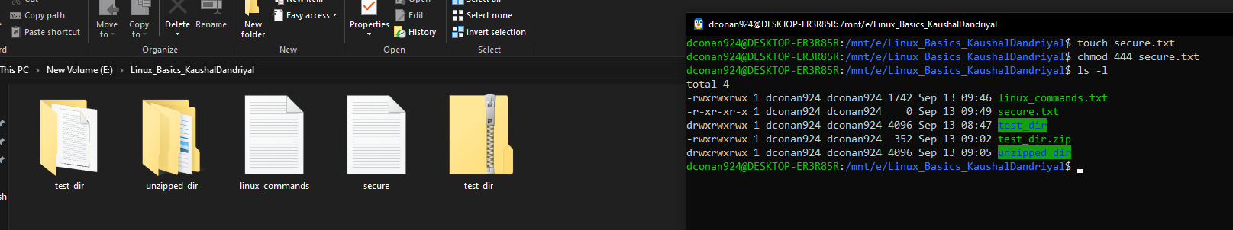

7. Working with Environment Variables
12. Use export to set a new environment variable called MY_VAR with the value “Hello, Linux!”.
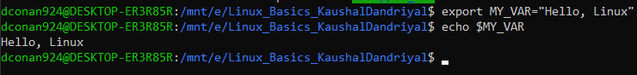

LINK TO THE GITHUB REPO:
https://github.com/kaushaldandriyal1610/Linux_Basics

